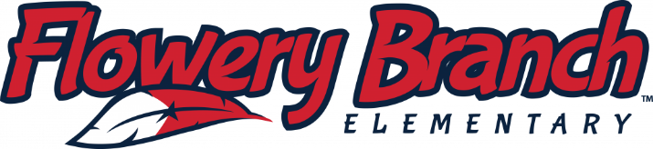

In case you couldn't make it to our Title I Parent and Family Engagement Input Meeting last week, you can watch the recordings below. There is an English recording and a Spanish recording. Thank you for your continued support of FBES.
English recording: rmd.me/sLXkGb9KsIO
Spanish recording: rmd.me/1PVn7bq2bt8

